*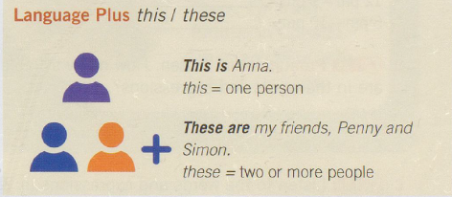****Introducing others.***

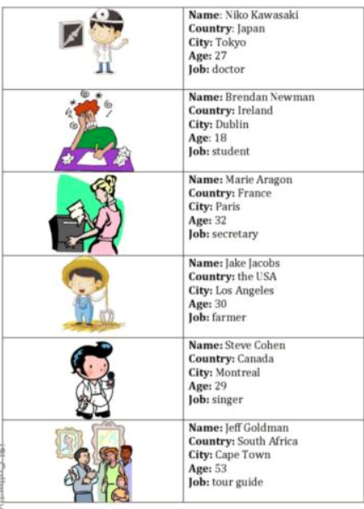

Let me introduce to you to…. Steve

I’d like you to meet…. Jeff

I know him/her/them from… Work/school/church

We used to … work/play together

What is his/her name? His name is Niko / Her name is Marie

Where is he/she from? He is from Japan.

Where does she live? She lives in Paris

How old is he/she? She is 32 years old.

What does he do for a living? He is a doctor.